**Lab Assignment 2**

This web application is designed to provide user to get the direction between the places and also weather details of the corresponding location. User has to login to use this feature, If the user want to login for the first time he initially has to register his details and then login

**Wire Frames:**

**Login Page:**

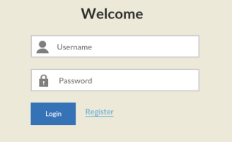

**Login Failure Page:**

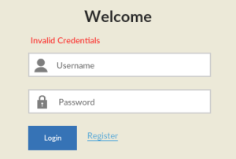

**Registration Page:**

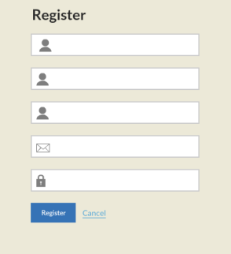

**Registration Success Page:**

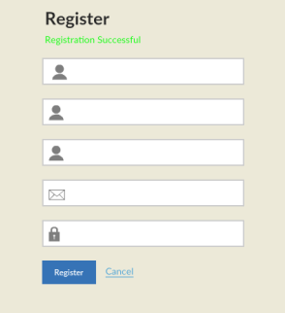

**Registration failure Page:**

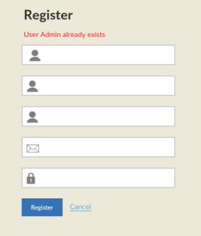

**Home page:**

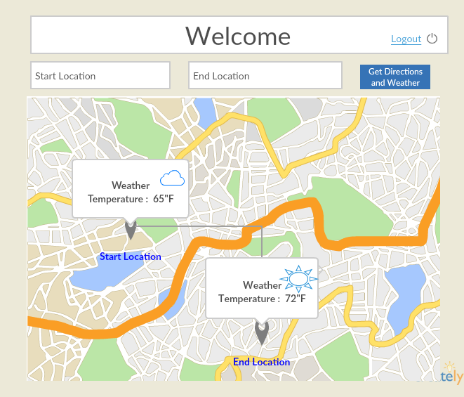

**Web Application Pages:**

**Login Page:**

This is the Login page of the Web Application. This page contains two text fields to enter Username and Password. If you enter valid credentials and then click “Login” button it will direct to the Home page. If You click on Register Link it will direct to the Registration page.

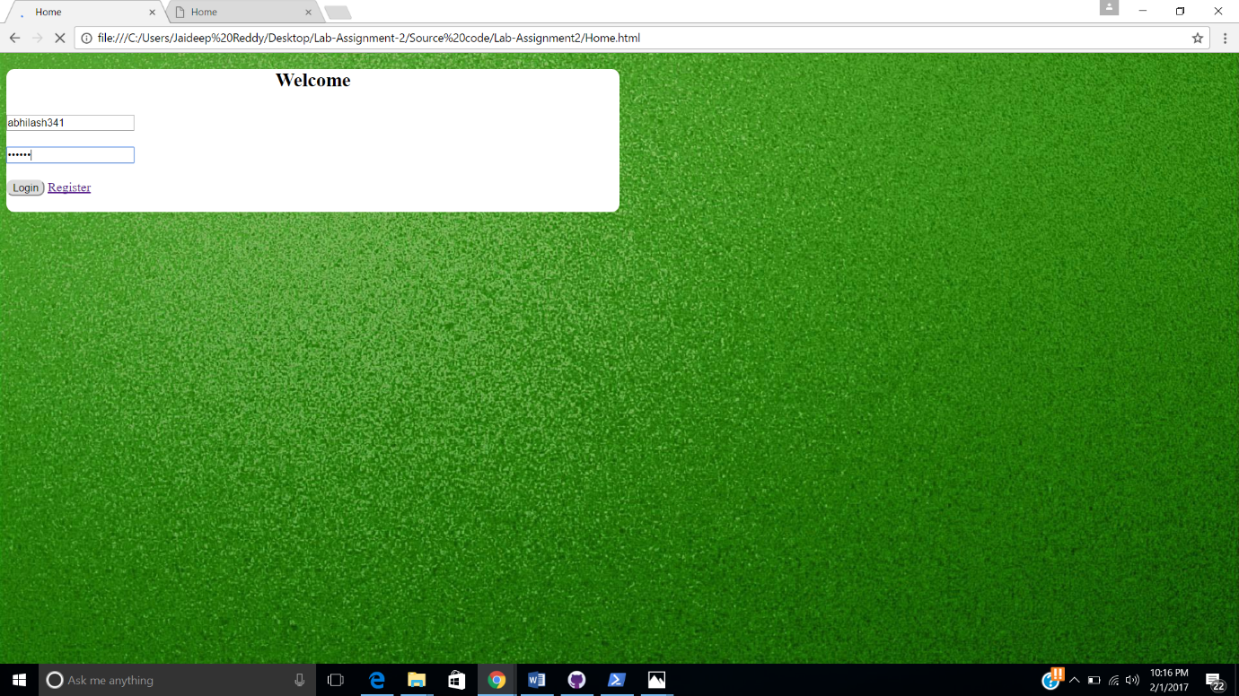

**Login Failure Page:**

If you enter Invalid credentials and try to login It will direct to the Login Page and Display a message stating that the credentials are invalid.

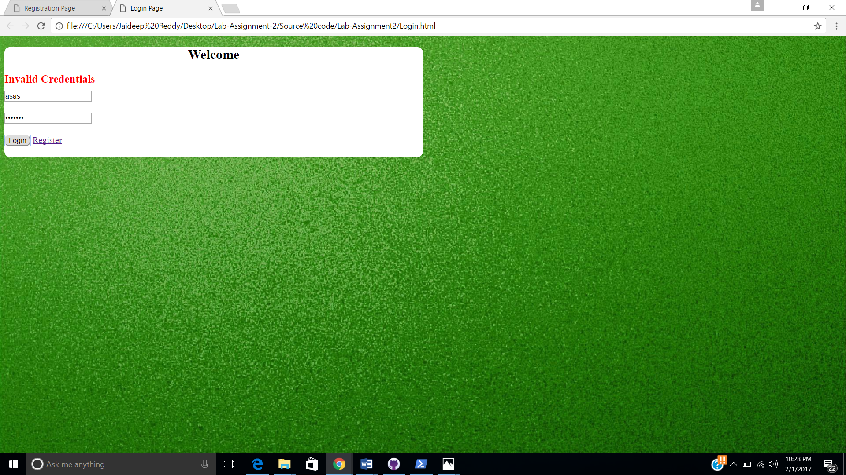

**Registration Page:**

If you are logging in for the first time if you click on register link in the Login Page it will get directed to the Registration Page. You have all your basic details and then click “Register”. If you want to cancel the Registration then click on “Cancel” lick which will direct to the Login Page.

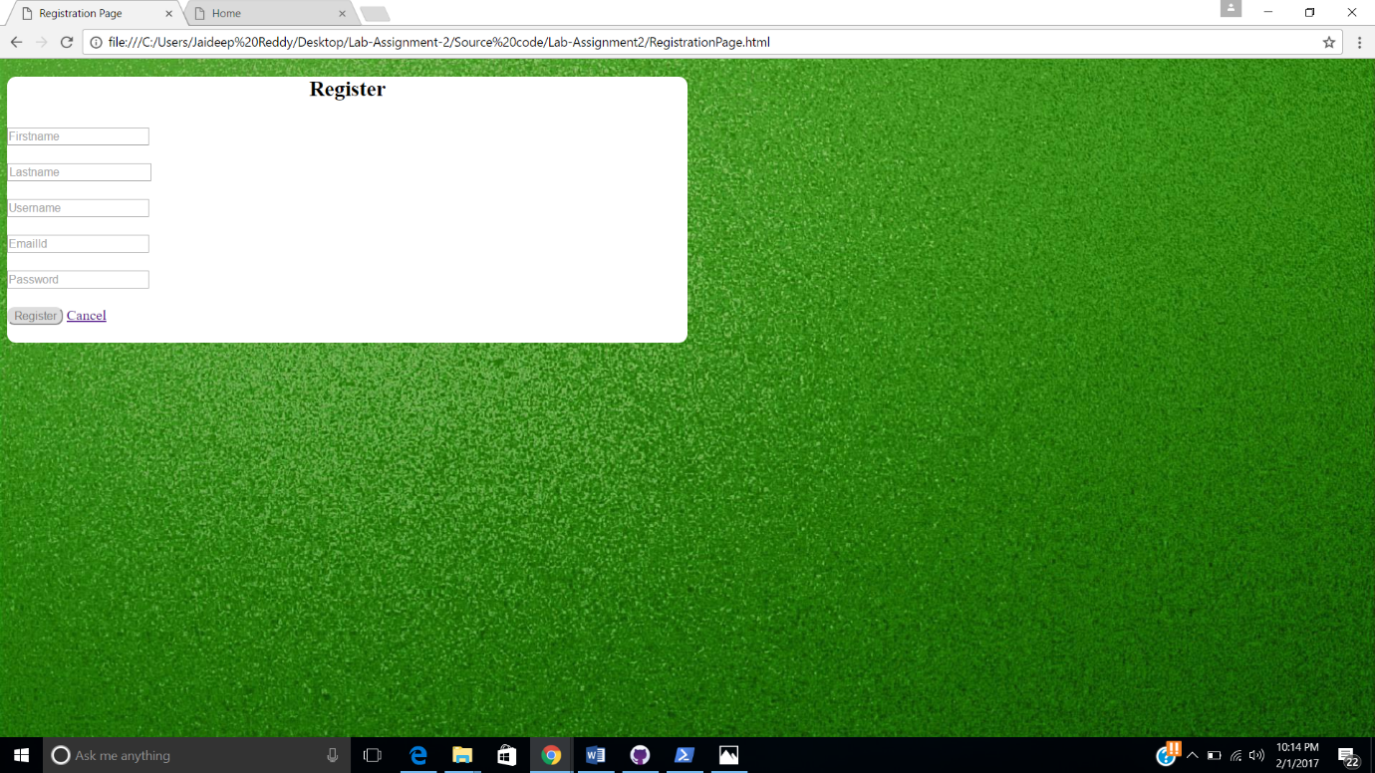

**Registration Success page:**

If you enter all the details and if there is no user with the existing name then the registration is done successfully. It will direct to the Registration Page and display a message stating that the “Registration Successful”.

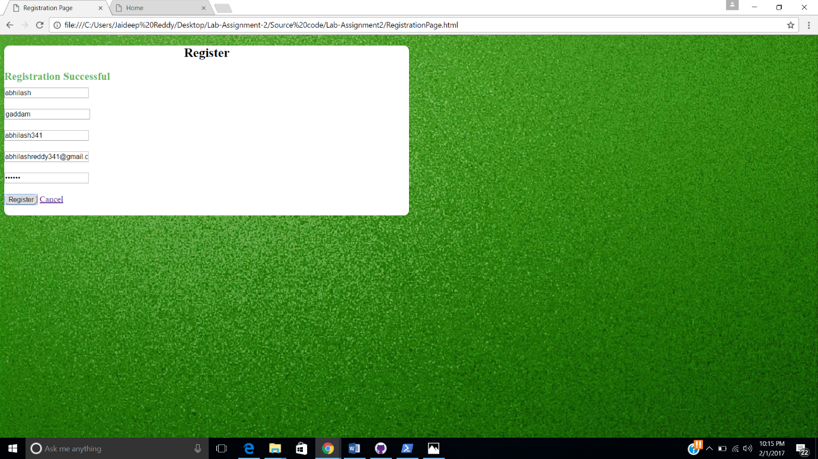

**Registration Failure Page:**

If any user with the name already has registered then your registration could not be done. It then directs to the Registration Page and display a message stating the “User Admin already exists”.

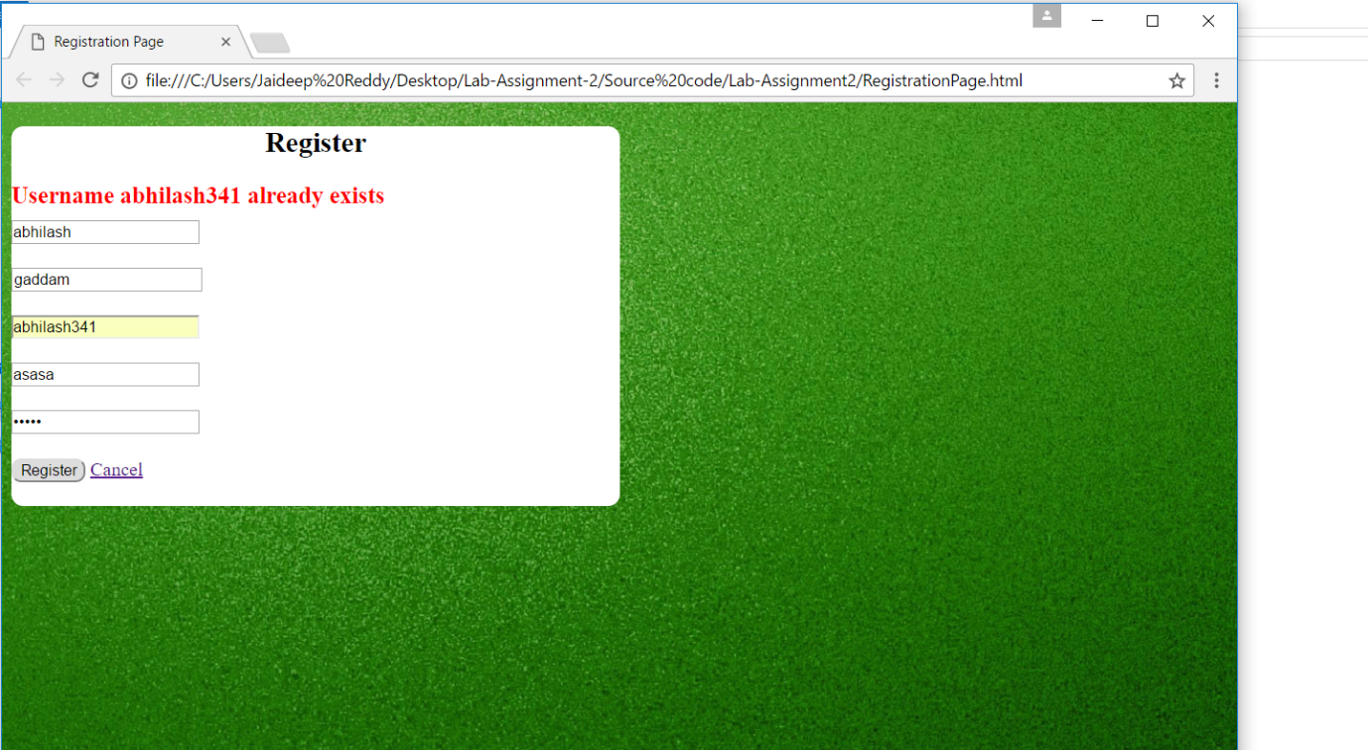

**Home Page:**

This page displays a map and has two text fields to enter start and end Locations. The start and end locations have auto complete feature. On selecting two locations and if you click on “Get Directions and Weather” button. It displays the direction between two locations and also displays the weather details of the two locations. We also have a logout button which directs to login page if a new user wants to access it.

